**Brooklyn torah gazette**

**For parshas vayigash 5783**

Volume 7, Issue 16 (Whole Number 323) 7 Teves 5783/ December 31, 2022

**Printed L’illuy nishmas Nechama bas R’ Noach, a”h**

For a free subscription, please forward your request to [***keren18@juno.com***](mailto:keren18@juno.com)

Past stories can be found on the website **ShabbosStories.com**

**All I Need**

**By Rebbetzin Esther Juingreis**

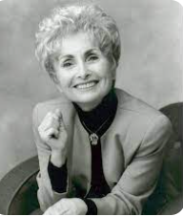

Do you have all that you need? Do you really have it? Every morning we make a brachah thanking the Almighty for providing us with all that we need. That sounds a little simplistic, you may protest. Is there anyone who feels that G-d has provided him with everything he needs? We all have items on our “shopping list”: health, sustenance, a marriage partner, children…a new apartment, a new car, a vacation, a new wardrobe — the list is endless.

So how can anyone say, with certitude and gratitude, “she’asah li kol tzorki — G-d provided me with my every need”? If we do not feel that G-d grants us our needs, it is because we don’t quite understand what those needs are. We suffer from a terrible human failing: We fail to recognize what we have, and see only what we don’t have — so we’re not satisfied.

“Eizehu ashir?” Chazal ask in Pirkei Avos. “Who is wealthy? Hasamei’ach b’chelko — he who is satisfied with his lot.”

The problem is that most of us do not know what our portion is — so how can we rejoice in it? We are always looking for something else and do not appreciate what we have. Indeed, that is the principle upon which our materialistic society is built. Create more needs and greed…sell more, and sell even more. It’s a vicious cycle that leaves vapidity, a purposeless life, in its wake.

**A Grand Prize to Visit New York in High Style**

Allow me to share an allegory. There once was a country boy who had never seen the big city, never flown on a plane. One day, through unexpected fortune, he was notified that he had won a grand prize: an invitation to visit New York, where he would be wined and dined and perhaps even offered a job. Thrilled beyond words, he searched for a sack in which to pack his few meager belongings. A friend of his drove him to the airport, where he was dumbstruck by the tumult, the many passengers, the security precautions.

Once in the air, he kept pinching himself and wondering, “Is this real? Could this be? Am I sitting here, or am I dreaming?” Soon enough, the pilot announced that the plane would be landing. A flight attendant came and helped him buckle his seat belt. When the plane landed, he asked where he could find his sack of clothing, and was directed to the baggage pickup, where he saw the carousel going round and round. He spotted his torn sack…but he also saw many beautiful suitcases.

Why should I take my old, torn bag? he mused. Let me take one of these suitcases instead. How will anyone know that it’s not mine? Excitedly, he grabbed an elegant-looking piece of luggage and speedily made his way to the exit. No one stopped him, and he got away with the pilfered piece. A well-dressed gentleman met him outside, drove him to a hotel, and told him that he’d be back in two hours to take him out to dinner.

**Eagerly Opened the Fancy Suitcase**

Once in his room, the country boy looked down at the clothing in which he had traveled. Everything was crumpled and stained; some of the food he’d been served was splattered over his shirt and pants. Eagerly, he opened the suitcase, sure he’d find something very special inside.

He searched through it — and then came a terrible shock. He couldn’t believe it! The beautiful piece of luggage was filled with ladies’ clothing, high heels, and makeup! He was aghast. What should he do? He could not go to dinner with his hosts dressed in his stained and creased pants and shirt.

In his sack he had a suit, which wasn’t in the best condition, but at least it was his and it fit and was clean. If only I had my sack with the clean suit that I folded so carefully, he thought to himself. That would be just perfect! Now people will laugh at me when they see me all rumpled. If only… If only… But the sack was gone.

Many of us, much like this country boy, wish for things that do not suit our needs. We try to grab that which is not meant for us, and when we get it, we cry in dismay, “That’s not what I wanted!” But it’s too late. We threw away what we had, and now we have nothing.

G-d has given us all that we need, but we think we are “smarter” than He is and throw away what He has given us, only to soon discover that we have nothing to fall back on. In order to be satisfied with your lot, as Pirkei Avos teaches, you have to recognize it and be careful not to throw it away in the junk pile.

*Reprinted from the Parshas Vayeishev 5783 email of At the ArtScroll Shabbos Table. Excerpted from the new Artscroll book – “Be a Blessing - A Guide to Living One’s Mission to the Fullest” by Rebbetzin Esther Jungreis.*

**Thoughts that Count**

***His soul is bound up with his soul*** (Gen. 44:30)

Judah was pleading with Joseph not to imprison Benjamin, for it would be devasting to Jacob were Benjamin not to return. In trying to describe to Joseph the close relationship between Jacob and Benjamin, Judah made the above statement. The He brew word for "bound," keshura, has the same numerical value as the word "Torah." Through teaching Benjamin the Torah, Jacob and Benjamin's souls were bound, totally connected.

Joseph said, "I am Joseph, is my father still alive?" The brothers became frightened of him and were unable to answer. (Gen. 45:3)

Judah asked Joseph to have mercy on his elderly father, who might die of grief if Benjamin did not return, and release Benjamin. When Joseph revealed himself, he said, "I am Joseph -- whom you sold twenty-two years ago. Is my father still alive ? -- and what of the grief you caused him by not disclosing my whereabouts to him all these years? You plead to me to have mercy on him; where was your mercy?" The brothers couldn't justify this to him. *(HaRav Shmuel Pesach Bogomilsky)*

*Reprinted from the Parshat Vayigash 5758/1998 edition of L’Chaim. Excepted from “From Vedibarta Bam” by Rabbi Moshe Bogomilsky*

**Rav Avigdor Miller**

**on Hillel’s Anger**

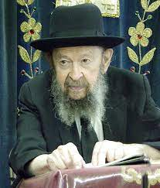

**QUESTION:** **It says that Hillel never became angry. How is it possible that he never became angry?**

**ANSWER:** You have to know that sometimes it pays to restrain your anger in order to perfect yourself. Sometimes you have to go to extremes in order to make progress and so Hillel made it a goal of his to never become angry because he was trying to perfect his character.

Now, you must know that when it says Hillel never became angry, it doesn’t mean it k’pshuto. Because sometimes Hillel had to put on an act as if he was angry. Like it says כעס הפנים ולא כעס הלב – anger that shows on the face, without anger in the heart. Sometimes Hillel had to show anger on his face. It can’t be helped; sometimes you have to show anger about something.

But sometimes the heart must be kindled too. In some situations, for the sake of Hakodosh Boruch Hu, the mind also must become angry. And therefore, what we’ll say is that Hakodosh Boruch Hu wanted to help Hillel out in his role as a model for the Jewish people, so He never gave Hillel any real nisayon (difficulties) in that sense. He had smaller nisyonos, like the Gemara says there, that when someone came to vex him, to insult him, so Hillel was able to control himself.

But Hillel didn’t have such a case where he had to speak up with anger l’chvod shamayim. You can be sure that if Hillel had been around in the time of Chanukah when the Greek officer came to offer a swine on the mizbei’ach in the streets of Modi’in, Hillel would have taken out his sword and he would have done no less than Matisyahu. He would have become angry for the honor of Hashem, absolutely! Only that Hakodosh Boruch Hu never gave him such an opportunity. All he had was minor conflicts with his fellow Jews, and he therefore restrained himself and never became angry.

*Reprinted from the December 19, 2022 email of Toras Avigdor (Tape #624 – December 1986).*

**The Eternal Connection**

**Between Judah and Joseph**

**From the Talks of the Lubavitcher Rebbe**

**Rabbi Menachem Mendel Schneerson, Zt”l**



This week's Torah portion, Vayigash, opens with the words "And Judah came near to [Joseph]." The Zohar comments that this encounter was not a simple meeting between individuals, but the symbolic coming together and fusion of two dynasties, that of Judah and of Joseph.

After the death of King Solomon, the Jewish nation split. Rechavam, King Solomon's son (a descendant of Judah), ruled in Judah, whereas Yeravam (of the tribe of Efraim, who was a son of Joseph) ruled the kingdom of Israel. The meeting between Judah and Joseph alludes to the reunification of the Jewish people in the Messianic era.

This theme is further elucidated in this week's Haftorah, in which the Prophet Ezekiel foretells of one king -- Moshiach, of the House of David (from the tribe of Judah) -- who will rule over a united Jewish people. The two "branches" of Judah and Efraim will be joined "one to another into one tree." "I will take the children of Israel from among the nations...and bring them to their own land. And I will make them one nation in the land...they shall no more be two nations... David My servant shall be king over them, and they will all have one shepherd."

In addition to the literal meaning of the prophecy, however, lies a deeper significance.

Chasidut explains that Joseph is symbolic of Torah study and Judah represents the performance of mitzvot. Our Sages debated as to which is more important, and concluded that at present, the study of Torah which leads to actual deed is greater. Nonetheless, in the Messianic era, deed will be considered superior.

**The World will Change with the Coming of the Moshiach**

When Moshiach comes the world will be essentially different from the way it is today. Instead of having to pore over our holy books for guidance, the knowledge of G-d will be so obvious that we will not have to study to know what to do! In the same way that an animal does not have to be taught to avoid fire, so too will it be natural to avoid what the Torah prohibits and observe its positive commandments.

The text itself attests to this: The Torah puts Joseph on a higher level than Judah ("Judah came near to him"), whereas the Haftorah, alluding to the Messianic era, describes King David (of the tribe of Judah) as the greatest of all.

In truth, when Moshiach comes, our "deeds" will be superior to today's deed and Torah study put together. Nowadays, no matter how diligently a person learns Torah, it doesn't completely penetrate his inner consciousness. But in the Messianic era, G-dliness will be so open and apparent that observing Torah and mitzvot will be entirely natural. At that time, Joseph (deed) and Judah (Torah study) will be completely united into one entity.

*Reprinted from the Parshat Vayigash 5758/1998 edition of L’Chaim. Adapted from Likutei Sichot.*

**Rabbi Berel Wein on**

**Parshas Vayigash 5783**



The statement of our father Jacob to the Pharaoh of Egypt that “my years of life have been few and most unpleasant” is most perplexing. We all know the well-known anecdote that one of the most disappointing things in life is to ask someone how he or she is and they actually tell you. One would’ve expected that Jacob would have answered the Pharaoh in a general, positive fashion.

Rashi interprets the answer of Jacob in the light of his deteriorated physical condition that he presented to the Pharaoh. He wanted Pharaoh to realize that the lines in his face were well-earned. He also wanted him to realize that the lives of even the most righteous of people and the holiest of families can also be troubled and difficult.

**The Lesson of Good Being it Own Reward**

He was teaching the Pharaoh the great lesson that in this world good is its own reward and that it does not necessarily carry with it physical comfort and emotional serenity. He was telling the Pharaoh not to judge him or his family by the shortsighted yardstick of material success and lifelong leisure.

This was his explanation of the great Jewish lesson, ‘that the race is neither to the swift nor success to those who deem themselves to be wise.’ The Pharaoh is accustomed to immediate reward and benefit, to royal garments and gilded chariots. Jacob informs him that that this is a false measure of life and achievement. Though Jacob lived a stormy and often tragic life, it is he who blesses the Pharaoh for he, Jacob, possesses the gift of the future and of immortality.

How sad it is if a person has to look back at one’s lifetime and feel that somehow life cheated him or that he deserved better! The ability to deal with the vicissitudes of life, its downs as well as its ups, in the strength of belief that everything is from the hand of our Creator, has always been the great characteristic of the Jewish people.

**Overcoming Life’s Difficulties for a**

**Legacy of Greatness and Immortality**

Jacob can look back upon the life of turbulence, disappointments and sadness and yet see for himself and his progeny greatness and immortal memory. The Pharaoh must have realized that a blessing from this old broken Jewish stranger was of enormous value to him in Egypt. Often times in history it is the unlikely and seemingly downtrodden individual who holds the key to future developments and to the correct worldview of situations and conditions.

As long as Jacob lives there will no longer be a famine that will affect Egypt. The Pharaoh must have undoubtedly realized the gift of this blessing to Egypt. But like many people who will receive blessings in this world, he seems not to be impressed sufficiently by the matter to change policies, attitudes or behavior.

But Jacob and his descendants will haunt Egyptian society for centuries until it finally will overwhelm it. This has been the lot and mission of Israel over its very long, troublesome but great history.

*Reprinted from this week’s website of rabbiwein.com*

**More Thoughts that Count**

***And they said to Pharoah, "We have come to sojourn in the land; for there is no grazing in your servants' flocks, for the famine is severe in the land of Canaan."*** (Gen. 47:4)

Jacob’s sons were trying to point out to Pharoah how severe the famine was. In normal times, people eat the fruits and vegetables while the cattle eat the grass. The famine was so terrible that the people were forced to eat the grass, and there was nothing left for the cattle. *(Rabbeinu B'Chaye)*

*Reprinted from the Parshat Vayigash 5758/1998 edition of L’Chaim. Excepted from “From Vedibarta Bam” by Rabbi Moshe Bogomilsky*

**What *Fiddler on the Roof***

**Gets Right – and Wrong**

**By Dr. Yvette Alt Miller**

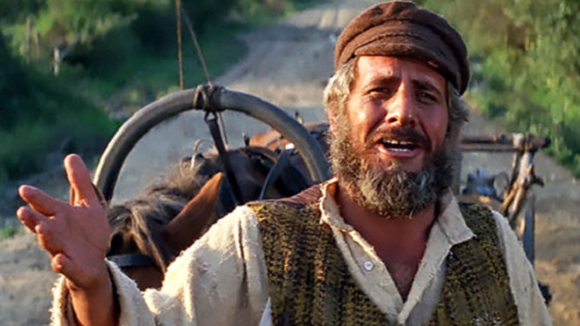

***The musical captures much of the joy of Jewish life and traditions, and gets some key points wrong as well.***

Growing up, a surprisingly large amount of what I knew about Judaism came from my favorite movie, *Fiddler on the Roof*.  The musical captures much of the joy of Jewish life and traditions, and gets some key points wrong as well.

Here are a few things *Fiddler* gets right, and two things it gets wrong.

**Based on Yiddish Stories**

The 1964 Broadway musical was based on stories written by the famous [Yiddish](https://aish.com/great-yiddish-expressions/) writer Sholem Aleichem.  His series of short stories about “Tevye the Dairyman” introduced readers to Tevye, a father living in a shtetl named Anatevka in an obscure corner of the Russian empire who’s “blessed with five daughters” as his character says with heavy emphasis in the movie, which came out in 1971.  (In the stories, he has seven.)

**Bottom of Form**

When it comes time to marry, Tevye’s daughters rebel, each pushing the envelope a little farther.  Tzeitel, the oldest, refuses to consent to marry the old widower Anatevka’s matchmaker picks out for her, insisting that she marry a young penniless tailor named Motel for love.  Tevye relents, concocting a crazy excuse for countenancing the marriage.

Next, his daughter Hodel refuses to marry a religious Jew, choosing instead to follow a young secular Jewish Communist named Perchik to Siberia.

Finally, at the end of the film, the next youngest daughter, Chava, breaks with Jewish tradition completely: she announces she’s marrying Fyedka, a non-Jewish local man.  In the Broadway musical and subsequent movie, Tevye agonizes, then ultimately gives his blessing to the match, telling the couple “G-d be with you.”  In the original stories, Tevye remains steadfast, refusing to countenance the match.  (The original stories are also darker in tone, with his other daughters suffering difficult trials and sad fates.)

Sholem Aleichem was the pen name of Sholem Rabinivitz.  Born in 1859 into a middle-class family in the prosperous town of Pereyaslav in the Ukraine, he grew up speaking Hebrew and Russian as well as Yiddish.  He always said he based his Tevye stories on a real-life milkman named Tevye he once met in a tiny Jewish shtetl who had a wry way of looking at the world and was committed to his Jewish religion.  Sholem Aleichem wrote him as a comic character and envisioned him being portrayed on stage; a 1919 [Yiddish play](https://aish.com/lost-world-of-yiddish-theater/) did capture Tevye’s stories to an appreciative Yiddish-speaking audience, followed by a Yiddish movie produced in 1939.

**Depicting Shabbat and Community**

By the time the Broadway musical and Hollywood film came along, the shtetls that Sholem Aleichem had describe were long gone: over 6 million Jews had been murdered in the Holocaust just a generation before.  Sholem Aleichem, like so many other European Jews, had moved to the United States.  In the 1960s and 1970s, many American Jews were abandoning the tight-knit bonds that had held them together in immigrant neighborhoods and were moving to more affluent, spacious suburbs.  *Fiddler on the Roof* came along at a time when nostalgia for the old ways of life was bumping up against the new, secular reality of American Jewish communities.

The musical conveys some of the joy of a traditional Jewish lifestyle.  One of my favorite scenes takes place late on Friday afternoon.  Tevye’s rounds have taken longer than usual because his horse is lame and he’s had to pull his heavy milk wagon himself.  As he approaches his ramshackle home, his wife Golde tells him, “Hurry up, it’s nearly the Sabbath!”  She’s already dressed in her fine Shabbat dress.

Golde looks regal, her dress adorned with a strand of pearls.  It’s a realistic scene in Jewish homes across the world each week: as sunset on Friday approaches, Jews don their finest clothes to prepare for a regal meal, as the lady of the home lights Shabbat candles.

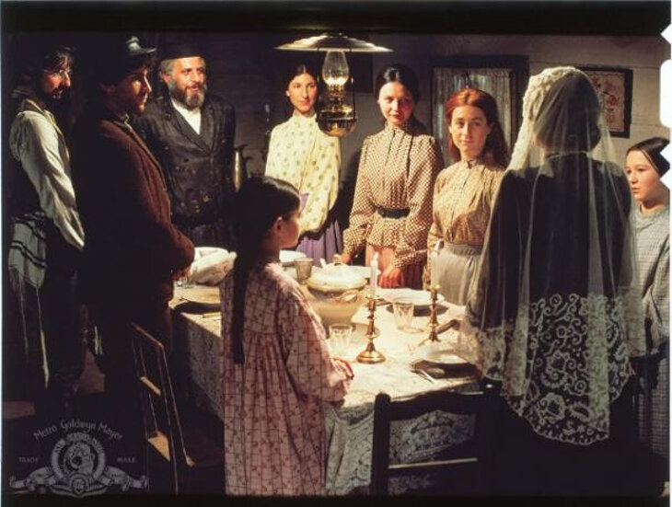

Tevye feeds his animals (singing *If I Were a Rich Man* as he works), then washes up and changes into his Shabbat suit and kippah.  He begins reciting prayers under his breath as he enters his home.  Usually shabby, tonight it looks beautiful. Typically, hard-working and harried, tonight Tevye and his family have time to relax and focus on one another.  Tevye and Golde bless their children and Golde makes a blessing over her Shabbat candles.  The musical gets the grandeur and holiness of Shabbat right.

*Fiddler on the Roof* also gets right the tightly-knit Jewish communities.  A traditional Jewish community fosters a lot of togetherness: men typically pray together three times a day with a minyan; children attend Jewish schools or classes; women get together to study and recite Psalms.  That community is evident in the world of *Fiddler* where the bonds that unite the dwellers of Anatevka are palpable.  Norman Jewison, the non-Jewish director of the film, described sitting next to Israeli Prime Minister Golda Meir (who grew up in a Yiddish speaking home in Ukraine) at the film’s premier screening in Israel, and watching her wipe away a tear.

**Do You Love Me?”**

One of my favorite songs in the musical is *Do You Love Me?*, sung by Tevye and his wife Golde after their daughter Hodel announces she is marrying a penniless young Jewish Communist named Perchik “for love,” without any involvement from a matchmaker or her family.  When Golde objects, Tevye tells her Perchik “is a good man…  I like him…  And what’s more important, Hodel likes him.  Hodel loves him.  So, what can we do?  It’s a new world.  Love.”  Tevye starts to get up then suddenly asks Golde if she loves him.

*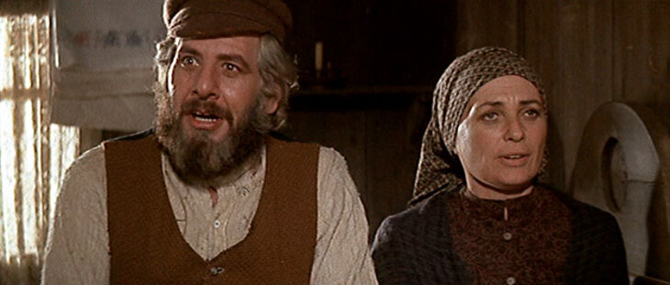****Do You Love Me?***

Singing, they describe their own arranged marriage 25 years ago, when their parents told them that eventually, love would grow.  “And now I’m asking, Golde, do you love me?” Tevye sings.  In response, Golde describes all the ways they’ve worked together through the decades: she’s milked the family cow, raised their children, cooked and cleaned, and so much more.”  “If that’s not love, what is?” she finally concludes.

Tevye - who’s slaved away through the years as well, building their family - gazes at her fondly as they finally realize they’re in love: “It doesn’t change a thing, But even so, After 25 years, it’s nice to know.”

This touching song conveys a deep Jewish truth: [love grows through giving](https://aish.com/what-is-love-3/).  The Hebrew word for love, *ahavah*, has as its root the word *hav*, “give.”  Giving to another person helps us keep their needs and perspective in mind, and fosters closeness.  When we give to another person, and particularly when we make the series of commitments to our spouses that marriage demands, we begin to foster the deep, abiding love that comes from being true life partners.

**Getting Torah Right - and Wrong**

A lot of *Fiddler on the Roof’s* comedy comes from Tevye’s bumbling through quotes about Jewish topics.  “As Abraham said, ‘I am a stranger in a strange land…’” Tevye confidently intones in one scene, only to be told that it was Moses who said that.  “Ah.  Well, as King David said, ‘I am slow of speech, and slow of tongue,’” Tevye replies - only to be told that this too was said by Moses.  “For a man who was slow of tongue,” Tevye replies testily, “he talked a lot.”

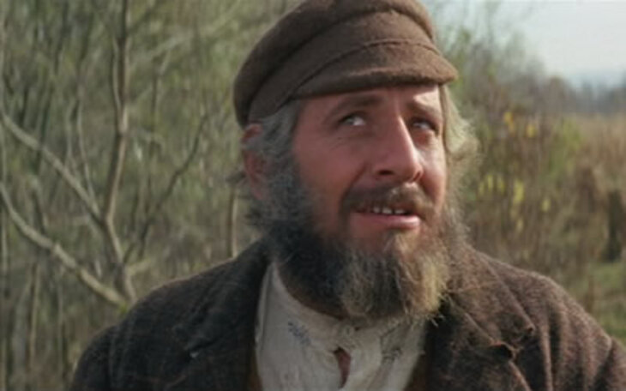

The denizens of Anatevka are steeped in religious discourse, but in the Broadway and movie version there’s never any indication that they take it too seriously.  The town’s rabbi is elderly and out of touch, and religious comments are confined to Tevye’s garbled pronouncements.  That is a far cry from the way life was in actual shtetls and even different from the Tevye in Sholem Aleichem’s writings.

“On the Shabbat, I tell you, I’m a king,” Tevye proclaims in the short story *Tevye Strikes it Rich*, before describing the Jewish books he studies on Shabbat: “The Bible, Psalms, Rashi, Targum, Perek, you-name-it….”  It’s a far cry from the more ignorant Tevye of modern depictions.

The writer Pauline Wengeroff (1833-1916) wrote about her life in the type of close-knit Yiddish speaking Jewish communities that *Fiddler on the Roof* refers to.  She and her husband were highly educated, fluent in German and Russian as well as Hebrew and Yiddish.  Yet her husband, like most of the Jews they knew, spent long hours prioritizing Jewish study.  “My parents were God-fearing, deeply pious, and respectable people,” she wrote in her masterful two-volume work *Memoirs of a Grandmother*.  “This was the prevalent type among the Jews then, whose aim in life was above all the love of God and of family.  Most of the day was spent in the study of Talmud, and only appointed hours were set aside for business….”

In a real-life shtetl like Anatevka, there would have been much more Jewish learning, and a greater familiarity with Jewish books and wisdom.

**More Than “Tradition”**

If there’s any song in *Fiddler on the Roof* that grates on my nerves, it’s the opening song *Tradition!*  “Because of our traditions, we’ve kept our balance for many, many years,” Tevye sings.  “Here in Anatevka we have traditions for everything - how to eat, how to sleep, how to wear clothes.  For instance, we always keep our heads covered and always wear a little prayer shawl.  This shows our constant devotion to G-d.  You may ask, how did this tradition start?  I’ll tell you - I don’t know!  But it’s a tradition….”

Nonsense.  A committed Jew like Tevye, who made the time to study Jewish texts, would be familiar with the sources for the Jewish practices he describes: he’d likely spend time studying about them each week.  Jews don’t live Jewish lives merely because of “tradition”.  On the contrary: they grappled with Jewish texts and eternal questions for most of their lives.

In Sholem Aleichem’s final Tevye story, after the residents of Anatevka have learned they must leave their town, Tevye is philosophical, relying on his deep faith to sustain him.  As he packs up to leave, he quotes the Torah and Jewish prayers.  He remembers how our ancestor Abraham was commanded by G-d to leave his family and his land too.  Tevya hopes for the coming of the Messiah.  And he takes our leave, saying he’s done talking, because now he has to go and be with his children and his grandchildren, who need him.

Like him, they were living a rich Jewish life, not out of tradition, but based in a deeply-held commitment to Jewish ideals.

*Reprinted from the December 18, 2022 posting on aish.com*